**1. INTRODUCTION**

* 1. **PROJECT OVERVIEW**

This live project can be used in specific organization which provides internship program. Admin or HR manager will be the main user who will use this application, as well as an intern will be able to view his/her records once registered. HR manager will mainly use this application to store and view interns records on regular time intervals. Based on that first of all HR will enroll the intern, further faculty will be assigned to intern on the selection of course. HR manager can also register new faculty if any employee joins the organization. Moreover HR manager can also add new courses if any course is being introduced in the organization. Interns can login, view their records and can request for leave if they want. Interns can also give a feedback if they need any changes in the teaching method or any other issues related in organization.

* 1. **OBJECTIVE**

The main objective of this application is to provide mobility environment to organization. In this application HR manager will manage details of interns on any android device. Details of interns will be easily accessed anytime and from anywhere as it is stored on server. As there is no use of any kind of paper work this application provides a smart interface to HR. Besides this time would be managed more sufficiently as there is no need to find records in files, instead of HR can simply login and assess needed records.

* 1. **SCOPE**

This is an android application which will be used to handle details of interns who are interested in internship in the organization. It consists of enrolment of student, on which project he/she is working (project details), on which platform the project is built, project guide in charge and constant evaluation of interns on the basis of completion of project. As it’s an android application the scope is only up to android devices like mobile device, tablet and many more. We cannot use this application on other operating system.

**1.4 TOOLS AND TECHNOLOGY**

**1.4.1 ANDROID INTRODUCTION**

Android provides a rich application framework that allows us to build innovative apps and games for mobile devices in a Java Language environment.

Android apps are built as a combination of distinct components that can be invoked individually. For instance, an individual activity provides a single screen for a user interface, and a service independently performs work in the background.

From one component you can start another component using intent. You can even start a component in a different app, such as an activity in a maps app to show an address. This model provides multiple entry points for a single app and allows any app to behave as a user's "default" for an action that other apps may invoke.

**1.4.2 ANDROID ARCHITECHTURE:**

Android operating system is a stack of software components which is roughly divided into five sections and four main layers as shown below in the architecture diagram.

**Linux kernel**

At the bottom of the layers is Linux - Linux 2.6 with approximately 115 patches. This provides basic system functionality like process management, memory management, device management like camera, keypad, display etc. Also, the kernel handles all the things that Linux is really good at such as networking and a vast array of device drivers, which take the pain out of interfacing to peripheral hardware.

**Libraries**

On top of Linux kernel there is a set of libraries including open-source Web browser engine Web Kit, well known library libc, SQLite database which is a useful repository for storage and sharing of application data, libraries to play and record audio and video, SSL libraries responsible for Internet security etc.

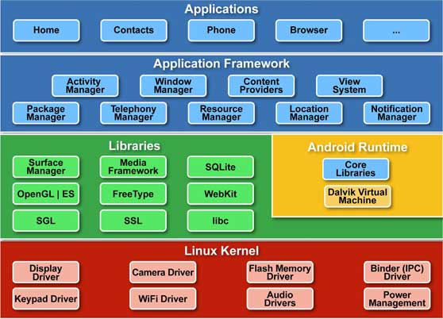

Fig: 1.1 Android Architecture

**Android Runtime**

This is the third section of the architecture and available on the second layer from the bottom. This section provides a key component called Dalvik Virtual Machine which is a kind of Java Virtual Machine specially designed and optimized for Android.

The Dalvik VM makes use of Linux core features like memory management and multi-threading, which is intrinsic in the Java language. The Dalvik VM enables every Android application to run in its own process, with its own instance of the Dalvik virtual machine.

The Android runtime also provides a set of core libraries which enable Android application developers to write Android applications using standard Java programming language.

**Application Framework**

The Application Framework layer provides many higher-level services to applications in the form of Java classes. Application developers are allowed to make use of these services in their applications.

**Applications**

We will find all the Android application at the top layer. We will write your application to be installed on this layer only. Examples of such applications are Contacts Books, Browser, Games and many more.